CO-ORDINATION IN PLANTS AND ANIMALS
Definitions
- CO-ORDINATION can be defined as the mechanisms in an organism that cause an appropriate response/reaction to a stimulus.
- IRRITABILITY (SENSITIVITY)
Irritability is the ability of an organism to perceive/sense and respond to stimuli. Or it is the ability to perceive and respond appropriately to changes in the environment. The environment can be internal [inside] or external [outside].
- External environment; this is the surrounding of an organism.
- Internal environment is the immediate surroundings of the body cells/tissue fluid in animals.
- STIMULUS
A stimulus is a change in environmental conditions that brings about a response. These may include temperature, moisture, gravity, pressure, tension etc.
- RESPONSE
A response is a change in activity or behaviour of part or the whole organism in relation to a stimulus.
Organisms must be sensitive to stimuli and respond appropriately in order to survive. If the response is directly towards the stimulus then it a positive response but if it’s away from the stimulus then it’s a negative response.
- RECEPTORS
These are structures /organs/cells of the organism that detect changes in the environment [stimulus]. external receptors are found on the body surface eg in the eyes, ears and skin while internal receptors are found inside the body ,which include stretch receptors in the lungs, stomach, urinary bladder and chemoreceptors in the blood vessels.
Types of Receptor | Stimulus received | Location of receptors
Chemoreceptors | Chemicals eg pH, salts/ions | Blood vessels
Mechanoreceptors | Touch, | skin
Thermo receptors | Heat | skin
Photoreceptors | Light | Retina of eye[rods and cones]
Stretch-receptors | Stretch/tension | Stomach, lungs, urinary bladder

- EFFECTORS:-these are structures in an organism that help them to react to the stimuli or these are structures that carry out a response. In animals these are the muscles and glands.
- IMPULSE:-is the electric message that is carried from the receptors to the effectors to cause a response in animals. its transmitted by the nerve cell
IRRITABILITY/ RESPONSE IN PLANTS
Unlike higher animals, plants do not possess nervous systems and they rely entirely on chemical coordination. Therefore, their responses are slow and mainly involve growth that results in the movement of organs. There are two types of plant responses i.e. tropisms and nastic.
NASTIES (NASTIC RESPONSES) IN PLANTS
Nastic response is movement of a plant part in response to a non-directional stimulus
Nasties include the opening and closing of leaves and flowers of certain plants in response to changes in light intensity (photonasty) or temperature (thermonasty) or touch (haptonasty).
Examples nastic responses
- the diurnal movement of leaves and flowers ie the closing of flowers when the temperature decreases, opening of primrose flowers at night
- The responses of insectivorous plants, such as the Venus fly to trap prey.
- Folding of the leaflets of the sensitive plant (Mimosa pudica) when touched. This is enabled by the pulvini, which are swellings at the bases of petioles and leaflets that get turgid due to osmotic in flow of water into their vacuoles

Nastic movement is generally caused by elastic changes in the size of special motor cells within the plant tissue. These changes are generally produced by changes in osmotic pressure that cause water to move in or out of the cells.
Importance of Nastic responses
- Nasties defend plants against herbivores,When herbivores touch a plant leaf and it folds, they may be frightened away
- Reduce transpiration.When plant leaves fold, they reduce the surface area for the loss of water through evaporation.
- Regulate temperature
Differences between nasties and tropisms
Nasties | Tropisms
Are elicited by non-directional stimuli | Are elicited by unidirectional stimuli
Occur relatively faster | Occur relatively slowly
Are wide spread in occurrence | Normally occur in shoot and root apices
Involve growth or turgor pressure changes | Involve only growth

TROPISMS RESPONSES IN PLANTS
A tropism (tropic response) is a growth movement of part of a plant in response to a unidirectional stimulus. Tropisms are named according to the stimuli involved.

Types of tropisms
A tropic response is named according to the nature of the stimulus. The five common tropic responses in plant are as below.
Stimulus | Light | Gravity | Water | Chemicals | Touch
Tropism | Phototropism | Geotropism | Hydrotropism | Chemotropism | Thigmotropism

Tropisms are described as positive if the growth (response) is directly towards the source of the stimulus. Tropisms are described as negative if the growth is away from the stimulus.

Nature of tropic response shown by plant parts
Stimulus | Positive tropic response | Negative tropic response
Light | Shoots bending towards light | roots
Gravity | Roots bending towards gravity | Shoots
Water | Roots to moist region | Some shoots
Chemical | Pollen tube formation
Touch | Tendrils of peas. Shoot of bean/peas | Root tip

IMPORTANCE OF TROPISMS
- The radicle grows downwards into the soil because it is positively geotropic thus enabling firm anchorage of the plant in the ground.
- Radicle also grows towards water because it is positively hydrotropic thus enabling water absorption for growth and photosynthesis
- The plumule grows upwards because it is negatively geotropic and towards light because it is positively phototropic thus phototropism exposes the leaves to maximize light absorption and enhance photosynthesis.
- Thigmotropism enables plants e.g. pea and passion fruit to get mechanical support as they touch and coil around the support

CAUSE OF TROPISM
Tropic responses are caused by the plant growth hormones called Auxins. Stimulus causes the uneven distribution of auxins in zone of cell elongation which in turn affect the rate of cell expansion at that particular part.
EXPT 1: TO SHOW THAT THE AUXINS (GROWTH HORMONES) ARE LOCARTED AT THE TIP
In this experiment two seedlings with straight coleoptiles were allowed to grow in total darkness for some time and observations made
After some time, the coleoptile tips were cut off and discarded on the agar plate which was then later placed back on one of the cut tip but on another the coleoptile was not placed back
Observations
- In the dark , the coleoptiles continued to grow straight upwards
- Coleoptile whose tip was not placed back stopped growing
- Coleoptile whose tip was replaced with the agar plate that has absorbed auxins, continued to grow

Deductions
The tips of coleoptiles produce growth promoting chemicals called auxins. Shoot tips are concerned with the growth of plants by providing new cells for growth.

EXPT 2: TO SHOW THAT IAA [indole acetic acid ] IS A GROWTH PROMOTER

Leave 13 lines

EXPT 3: TO INVESTIGATE THE EFFECT OF AUXIN DISTRIBUTION ON PLANT GROWTH
PROCEDURE
Seedlings with straight coleoptiles are selected; a razor blade is then inserted on one side B of the coleoptile tip and left to grow in the dark as show below. For the control, the coleoptile is let to grow without a razor blade inserted
Observations after three days
The coleoptiles continued to grow while bending towards the side with the razor blade which is side B. for the control the coleoptile continued to grow straight.

Leave 10 lines

Conclusion
Side B grows slower than side A causing it to bend towards side B
Explanation of the results
The razor blade prevents the movement of auxins on side B therefore growth on that side is reduced, causing the coleoptile to bend. The effect of uneven distribution of auxins is causing uneven growth of plants as verified by the experiment below.

EXPT 4: TO VERIFY THAT UNEVEN DISTRIBUTION OF AUXINS CAUSE UNEVEN GROWTH IN PLANTS SHOOT
PROCEDURE
Seedlings with straight coleoptiles are selected; the tip of one coleoptile A is removed by cutting and then replaced more on one side.
The tip of another coleoptile B is cut off and placed on the agar plate for some time to let auxins diffuse into the agar plate. The tip is then removed from the agar plates and the plate is then placed on one side of the coleoptile as shown below.
The tip of another coleoptile C is cut and discarded [not placed back]
The seedlings are left to grow in darkness for some time.

Leave 12lines

Observations
Coleoptiles A and B grow while bending towards the side without tips and agar plates as shown below but for C the shoot did not continue growing
Conclusion
More growth occurs in coleoptile tips with more auxins while less growth occur in coleoptile tips with less Auxins
PHOTOTROPISM
Phototropism is the plant growth movement in response to unidirectional source of light.
Experiment to demonstrate phototropism in plant shoots
A pot with three seedlings (with straight shoots) is placed in a dark box with one small opening for a few days.
In the control experiment, the potted plant is put on the clinostat and also let to stand for a few days
A clinostat is an instrument used to demonstrate that light and gravity are the stimuli responsible for phototropism and geotropism respectively. Its disc rotates clockwise to expose all parts of a seedling to equal stimulation from light or gravity hence cancelling their effects due to even distribution of auxins

Observation:
In the se-up with no clinostat, the shoots bend towards the direction of light
In the control (with clinostat) the shoot continues to grow straight.
Conclusion: Shoots are positively phototropic.
Explanation
Growth in the plant shoot is under control by growth substances called Auxins, found at the tip of the growing shoot. When the shoot is provided with light from one direction, the auxins move from the side with light to the side without light. Because growth in the shoot is favoured by high concentration of auxins, the side with the highest conc. of auxins grows faster as its cells elongate rapidly than the one with less. This causes the shoot to grow bending towards the light source. For the control, the rotating effect due the clinostat made the auxins to effect equal illumination of the sides of the shoot thus even auxin distribution which cause the same growth rate on all sides.

GEOTROPISM (GRAVITROPISM)
Geotropism is the plant growth movement in response to the force of gravity.
Experiment to demonstrate geotropism in plant shoot and root
Experimental procedure
- Bean seeds are allowed to germinate and three seeds with straight radicles are selected.
- They are arranged so that the radicle of one is horizontal, the second radicle points vertically upwards and the third radicle points vertically downwards as sown in the set-up below.
- Seeds are placed on moist cotton wool in a petri dish.
The whole set up is placed in a dark cupboard for two days.
- In the control experiment, the seedlings are put on a clinostat that is let to rotate slowly for 2 days
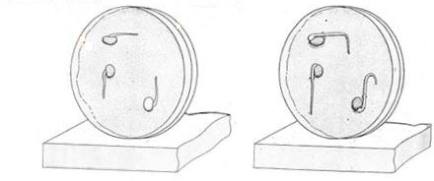

At start
After 2 days
Observation:
- The horizontal radicle curves downwards towards the pull of gravity.
- The radicle that was pointing vertically upwards also curves downwards.
- The radicle that was pointing vertically downwards continues to grow downwards
- In the control where the radicles are on rotating clinostat all radicles continued growing in their original direction
Conclusion: Roots are positively geotropic.
Explanation
If a seedling is placed horizontally on the ground, auxins diffuse from the upper side to the lower side due to the gravitational pull. Higher auxin concentration on the lower side inhibits growth in the root and the upper side with little or no auxins grows faster, causing the root to bend downwards but in the shoot, the auxins stimulate growth hence shoots bend upwards.
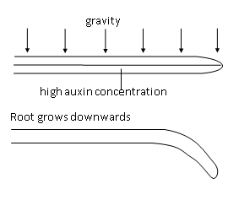
The graph summarizes the effects of auxin concentration on the growth rates of shoots and roots.
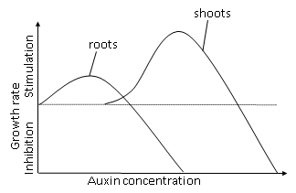
From the graph it is seen that at very low auxin concetration, root growth is supported but at moderate auxin concentrations root growth is inhibited and shoot growth is supported while at extreemly high levels of auxin the both the root and shoot growth are inhibited.
HYDROTROPISM
Hydrotropism is the plant growth movement in response to a unidirectional source of water. When a plant root is exposed to water from a given direction, the root grows bending towards the source of water, hence it is positively hydrotropic. When the plant shoot is exposed to the source of water, it grows bending away from the source of water, hence it is negatively hydrotropic.
Experiment to show hydrotropism
Viable seeds are planted in a large pot, 6 cm from a porous pot. They are watered adequately until the radicles and plumules appear. The porous pot is partially filled with water.
Observation: The roots grow inwards towards the water.
Conclusion: Roots are positively hydrotropic.
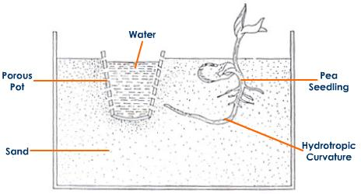

Explanation of Hydrotropism
When the plant shoot and the root are provided with water, auxins move from the side without water to the side with water. Because growth in the shoot is favoured by a high auxin concentration, the side with a high auxin concentration grows faster than the side with lower concentration. This enables the shoot to bend away and the roots to bend towards
Chemotropism is the growth of part of a plant in response to a chemical. An example is the growth of the pollen tube in response to the presence of sugars in the style.
Thigmotropism (haptotropism) is the growth of an aerial plant organ in response to localized physical contact. For example, when the tendril of the passion fruit touches a supporting structure, it coils around it. Therefore, the tendril is positively haptotropic.
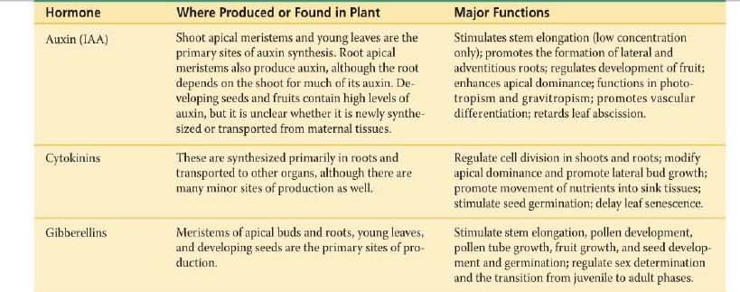
SOURCES AND EFFECTS OF PLANT HORMONES
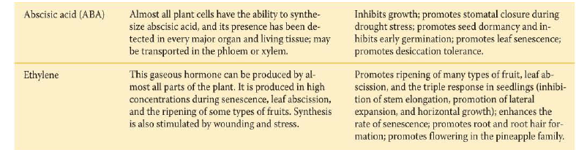

RECEPTION, RESPONSE AND BEHAVIOUR IN ANIMALS
Taxes (tactic responses)
The movement of a whole organism in response to a unidirectional stimulus is called a taxis. Taxes are classified according to the nature of the stimuli as illustrated in the table below.
Stimulus | Taxis | Example
Light | Phototaxis | Positive: Euglena swims towards light.  Negative: Cockroaches, earthworms and woodlice move away from light.
Chemicals | Chemotaxis | Positive: Sperms swim towards the ovum.  Negative: Mosquitoes avoid insect repellents.  Positive: Miracidia move towards freshwater snails.
Touch | Thigmotaxis
Temperature | Thermotaxis | Some small nematodes and slime moulds are sensitive to change in temperature and always move towards the preferred temp.
Water | Hydrotaxis | Some river fish are positively hydrotactic to avoid being swept away by the water current
Air | Aerotaxis | Aerobic bacteria are positively aerotactic

Taxes enable cells and organisms to move to favourable conditions.
There are two main distinct co-ordination systems in mammals
- The nervous system; which is a network of message conducting cells called nerve cells that are connected to all body parts.
- The endocrine system; which is made up of a system of glands that produce chemical substances called hormones for coordination
The interaction of the systems of the body in order to regulate internal functions and behaviour is called coordination. The nervous system and endocrine system effect the coordination, integration and control of physiological activities.

COORDINATION IN VERTEBRATES
The coordination of the body processes and actions in animals is achieved by two systems which include, the hormonal control system and the nervous control system. The hormonal control system uses hormones thus also called the chemical control system while the nervous control system involves electrical impulses being mediated through the nerves.
Chemical coordination in vertebrates [Hormonal control]
The endocrine system
This is the system of ductless glands that produce chemical substances called hormones. This system is under the control of pituitary gland which is there for known as the MASTER GLAND in the body because it controls the activities of all the glands in the body through the hormones it secretes.
A hormone is a specific chemical substance produced by one part of the body, enters the blood stream and is transported to a target organ, where it exerts a specific regulatory effect.
Endocrine glands are ductless glands stimulated to secrete hormones either by impulses from the motor nerves or by hormones from other endocrine glands. The endocrine system is linked to the nervous system by the hypothalamus, which exerts control over the pituitary gland.
Characteristics of hormones
- -protein in nature
- -produced and work best in minute quantities
- -secreted directly into the blood stream because they are ductless
- -produced by ductless glands/endocrine gland
- -effect on target organ is either stimulation or inhibition. i.e. they regulate the activities of the target organ.
GLANDS; these are tissues containing secretory cells that produce and secret chemical substances. or a group of secretory cells which produce useful substances in the body.
Types of glands
- exocrine gland (ii) endocrine glands
Exocrine glands; are glands that secrete their hormones to their target organs through their duct. i.e. Hence are called DUCT gland because they have ducts. e.g.
- -pancreas gland has pancreatic duct that carries its pancreatic juice into the duodenum.
- -salivary gland has salivary duct that carry the saliva into the mouth cavity
- -Sweat gland has a sweat duct and pore through which sweat passes
- -gastric glands
- -Tear gland
- -mammary glands
Illustration of glands
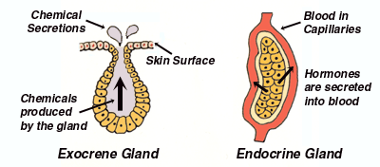

2. Endocrine glands:-these are ductless glands that secrete their hormone directly into the blood stream. The blood carries the hormones from the glands to their target organs after circulation in the whole body. Examples of endocrine glands: pituitary gland, thyroid gland, gonads [testes and ovary], pancreas
Diagram showing position of endocrine glands in a mammal/human
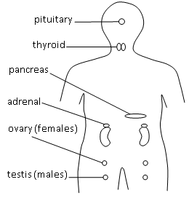

Functions of the different glands
- Pituitary gland:- This is an outgrowth at the base of the brain. It is known as the master gland because it secretes several hormones, which regulate the activities of other endocrine glands.
Hormone Gland Origin |  | Target Tissue | Function

Adrenocorticotropic | Pituitary gland (anterior) | Adrenal cortex | Triggers secretion of hydrocortisone from the adrenal gland
Growth hormone  (somatotrophin) | Pituitary gland (anterior) | Throughout body | -Stimulates growth by elongation of bones (long bones )of the limbs &multiplication of body cells and dev’t.  -Stimulate protein synthesis. Excess secretion of G.H cause gigantism. under secretion of G.H cause retarded growth a condition dwarfism Excessive secretion in adults results in acromegaly, which is characterized by the thickening of the bones of the hands, feet and jaws.
Follicle-stimulating hormone(FSH) | Pituitary gland (anterior) | Sex glands | Stimulates female egg maturation and male sperm production[maturation of graafian follicle]
Luteinizing hormone | Pituitary gland (anterior) | Sex glands | Stimulates female ovulation and male secretion of testosterone
Prolactin | Pituitary gland (anterior) | Mammary glands | Stimulates milk production in the breasts after childbirth
Thyroid-stimulating hormone(TSH) | Pituitary gland (anterior) | Thyroid gland | Triggers secretion of thyroid hormone which increases metabolic rate, releasing thermal energy that rises body temperature
Melanocyte-stimulating hormone | Pituitary gland (anterior) | Melanin-producing cells | Controls skin pigmentation
Antidiuretic hormone  (ADH) vasopressin | Pituitary gland (posterior) | Kidneys | Regulates water retention and blood pressure
Oxytocin | Pituitary gland (posterior) | Uterus  Mammary glands | Triggers contraction of the uterus during labor  Stimulates milk letdown for breast-feeding after childbirth

2. Thyroid gland:-its located in the ventral side of the neck. It secretes thyroxine hormone.
Hormone gland origin target tissue functions
Calcitonin | Thyroid gland | Bones | Controls the level of calcium in the blood by depositing it in the bones
Thyroxine  Hormone | Thyroid gland | Throughout body | -controls the body's metabolic rate(BMR);  -Controls mental, normal growth and physical development
Parathyroid hormone | Parathyroid glands | Bones, intestines, and kidneys | Regulates calcium level in blood

Note
- Under production of thyroxine hormone results in a condition known as hypothyroidism/goitre. Goitre, disease of the thyroid gland, characterized by an enlargement of the gland, visible externally as a swelling on the front of the neck. It’s caused by lack of enough iodine in blood, which is required for the synthesis of thyroxine hormone. This leads to excess multiplication of thyroid cells hence swelling of the thyroid gland a condition known as goitre. In children underproduction leads to poor physical growth, mental retardation, leathery skin, deformed legs, large tongue, a Condition known as cretinism. In adults it leads to decreased rate of metabolism which causes obesity
- overproduction of thyroxine hormone cause a condition known as hyperthyroidism which leads to increased rate of metabolism leading to loss of weight/very thin ,increased pulse rate ,breathing rate, high body temperature and in some situations heart failure, Protruding eyes, Enlarged thyroid glands /goitre, restlessness and increased irritability
REMEDY; By surgical removal of the thyroid gland or destroying it using radioactive iodine

3. ADRENAL GLAND: it’s found attached to the kidney,
Hormone gland origin target tissue functions
Aldosterone | Adrenal gland | Kidneys | Regulates sodium and potassium levels in the blood to control blood pressure
Glucocortisone/  Cortisone | Adrenal gland | Throughout body | Plays key role in stress response;  increases blood glucose levels in blood n case of starvation and increase conversion of fats and proteins into glucose./mobilizes fat stores; reduces inflammation  -increases the blood glucose level by promoting gluconeogenesis (conversion of non-carbohydrate substances e.g. proteins to glucose).
Adrenaline hormone | Adrenal gland | Muscles and blood vessels | -Increases blood pressure and heart rate; constricts blood vessels  -prepares the mammals to fight/take off/for excitement by  i) Increasing heart beat to increase supply of materials, oxygen and sugars to skeletal muscles.  ii)increasing blood sugar to increase energy production  iii)dilating the coronary arteries to increase supply of oxygen and sugars  iv) Dilating of the pupils for clear vision.  v)increases the rate and depth of breathing to ensure more oxygen is taken to the respiring cell in order to release more energy  vi) Stimulates the conversion of glycogen to glucose.  vii) Dilates the blood vessels that supply the brain and muscles. Viii) Diverts the blood from the alimentary canal and skin to the muscles.

4.PANCREAS:-The cells that produce hormones in the pancreas are called islets of Langerhans. They contain two types of secretory cells i.e. beta cells that secrete insulin and alpha cells that secrete glucagon. Insulin and glucagon have antagonistic effects on the level of glucose in the blood.
How does Insulin decreases the glucose concentration ?
▪stimulates the liver cells to convert excess glucose to glycogen by a process called glycogenesis.
▪Increasing the rates of conversion of glucose to fats that are then stored in adipose tissues under skin.
▪Promoting the oxidative breakdown of glucose by increasing the metabolic rate
How doe Glucagon increase the glucose concentration?
▪Promoting breakdown of glycogen to glucose a process called glycogenolysis.
▪Promoting synthesis of glucose from other organic molecules like proteins and lipids a process called gluconeogenesis.
▪Reducing the rate of the oxidative breakdown of glucose ie reduced metabolism.
What are the effect of abnormal levels of insulin in the body?
Insufficient secretion of insulin hormone/Failure of the pancreas to produce enough insulin in the body causes increased blood sugar in the blood a condition called diabetes mellitus. Symptoms of diabetes mellitus Excreting glucose in urine(sweet urine, obesity/impotence in males , General body weakness but insulin is Excess in the body ;low blood glucose level
Hunger, sweating, Double vision
Note : The pancreas also secretes hormones through pancreatic duct directly into the blood vessels hence both an endocrine gland and exocrine gland.
5. GONADS;-These are sex glands i.e. i) testes for males.
ii) Ovary for females.
Testes: these glands of mammals are hanging out of the core body to maintain slightly lower temperature compared to the core body temperature that is suitable for sperm production.
Hormone gland/origin target tissue functions
Oestrogen | Ovaries | Female  reproductive  system | Causes sexual growth and development;  -controls growth of female secondary sexual x-tics  e.g. growth of uterus & breasts,dev’t of pelvis(hips),growth of pubic hair, dev’t of reproductive organs, peeling and repair of uterine wall after mentration,dev’t of sharp/softening voice, enlarging of the vagina.  -maintains proper functioning of female reproductive system
Progesterone | Ovaries | Mammary glands  Uterus | -Prepares uterus for pregnancy.  -Inhibits ovulation and maintains pregnancy
Testosterone | Testes | Throughout body | -Causes sexual growth and development;  -increases sperm production.  It leads to dev’t of secondary sexual x-tics in males such as i) growth of public and facial hair  - muscular dev’t,deepening of voice,dev’t of sex organs, enlargement of penis,growth of beards  maintains proper functioning of male reproductive system
N.B: MALE AND FEMALE hormones occur in either sex but different concentrations.
If a female has more male hormones above the normal levels, she develops male secondary sexual x-tics e.g. deep voice, beards.
If a male has more female hormones above the normal levels, he develops female secondary sexual x-tics. e.g. sharp voice, big bums, and tender muscles.
NERVOUS SYSTEM
The nervous system has three main functions:
▪It provides a means of communication between the receptors and effectors.
▪It controls and coordinates response to stimuli.
▪It brings about conscious thought.
The nervous system has three types of specialized cells (receptors, effectors and neurones). Receptors (sense cells) detect stimuli. Exteroceptors are receptors that detect external stimuli like light, sound and heat. Interoceptors detect internal stimuli e.g. sugar level, osmotic pressure and carbon dioxide concentration. Effectors are cells that respond to stimuli e.g. muscle cells and gland cells.
Neurones
The neurones are the structural and functional cells of the nervous system. They transmit impulses (electrical messages) between the receptors and effectors.
Types of neurones
- sensory (afferent) neurones receive impulses from the receptors and transmit them to the central nervous system.
- The motor (efferent) neurones transmit impulses from the central nervous system to the effectors.
- The relay neurones are found in the central nervous system where they associate the sensory and the motor neurone. they are also called: association (intermediate) neurones.

Neurones integrate (interpret) information from environmental stimulation of the receptors and associate it with appropriate responses. The nucleus located in the cell body controls the activities of the neurone. The elongated parts of neurones are called nerve fibres. The part of a neurone that conducts impulses towards the cell body is called a dendron. The part of a neurone that conducts impulses away from the cell body is called an axon. The myelin sheath is a fatty part that protects and insulates the nerve fibre. It also speeds up the transmission of impulses. The Schwann cell synthesizes the myelin sheath. The dendrites are branched cytoplasmic projections that receive impulses from the adjacent neurones. The terminal dendrites communicate with the adjacent neurones, receptors or effectors via microscopic gaps called synapses.

A nerve is a bundle of neurones ensheathed in connective tissue. A sensory nerve consists of sensory neurones. A motor nerve consists of motor neurones. A mixed nerve consists of sensory neurones and motor neurones.
Illustrations of the sensory and the motor neurones
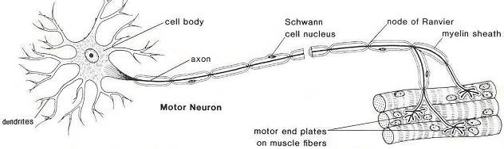
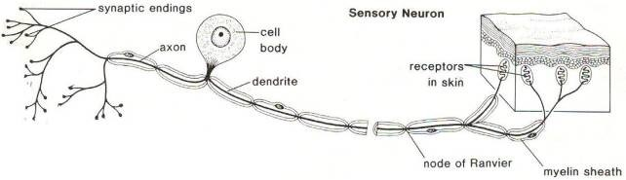

Differences between a sensory neurone and a motor neurone
Sensory neurone | Motor neurone
The terminal dendrites connect with the relay neurones | The terminal dendrites connect with the effectors
The cell body is peripheral | The cell body is terminal
It has one long Dendron | It has several short dendrons
The axon is shorter | The axon is longer
It is unipolar (one structure arises from the cell body) | It is multipolar (several structures arise from the cell body)
It conducts impulses from the receptors to the central nervous system | It conducts impulses from the central  nervous system to the effectors
COMPONENTS OF THE NERVOUS SYSTEM
The mammalian nervous system consists of the central nervous system and peripheral nervous system. The central nervous system consists of the brain and spinal cord. The peripheral nervous system consist of somatic and autonomic where the autonomic is divided into sympathetic and parasympathetic nervous systems.
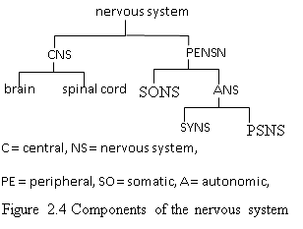

THE BRAIN
The brain provides the integrative power that underlies complex behaviour characteristic of mammals. It is an enlarged, specialized front region of the spinal cord surrounded by three protective membranes called meninges. The space between the innermost meninge and second meninge is known as the subarachnoid space. It contains the cerebrospinal fluid (CSF) that acts a shock absorber, supplies nutrients to the brain and removes wastes from it. It is similar to the tissue fluid in composition. An infection of the meninges called meningitis is fatal.
The human brain is made up of three parts; forebrain, midbrain and hindbrain.

- The forebrain (known as the cerebrum) is the largest part. It consists of the right and left cerebral hemispheres. A band of white matter (nerve fibres) that links the two hemispheres is known as the corpus callosum (Figure 2.3). It facilitates the transfer of information from one hemisphere to another.
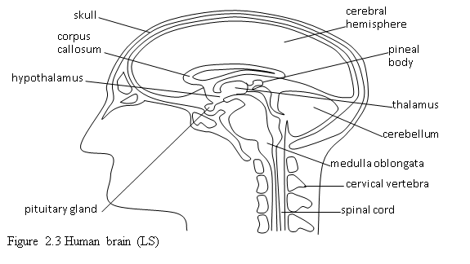
The cerebrum:
▪Controls the voluntary activities.
▪Receives impulses from the senses of touch, sight, taste and hearing.
▪Is a centre for memory, learning, reasoning, imagination, judgment and personality.
▪Is concerned with the perception of pain and pleasure.

- The midbrain consists of the hypothalamus and olfactory lobes.
The hypothalamus:
▪Monitors and regulates the temperature of blood.
▪Monitors and regulates the osmotic pressure of blood.
▪Controls the release of hormones by the pituitary gland.
▪Is a centre for speech and feelings like thirst, hunger, sex drive and sleep.
The olfactory lobes receive and integrate information from the sense of smell.

- The hindbrain consists of the cerebellum and medulla oblongata.
The cerebellum:
▪Coordinates information from the ear about body posture and balance.
▪Controls rapid muscular activities such as writing, talking and typing.
The medulla oblongata controls the involuntary actions.
THE SPINAL CORD AND REFLEX ARC
This is a cylinder of nervous tissue running from the base of the brain to the lumbar region. It is protected by the meninges and vertebral column. In cross section, it consists of two parts.
- The grey matter is an H-shaped central core composed of neurones’ cell bodies and dendrites surrounding the spinal canal that contains the cerebrospinal fluid.
- The white matter is the outer layer containing nerve fibres whose myelin sheaths give it the characteristic white appearance. The sensory neurones enter the spinal cord via the dorsal root where their cell bodies form the dorsal root ganglion. The motor neurones leave the spinal cord via the ventral root and their cell bodies are in the grey matter. A ganglion is a swelling along a nerve consisting of many cell bodies.
Illustration of reflex arc
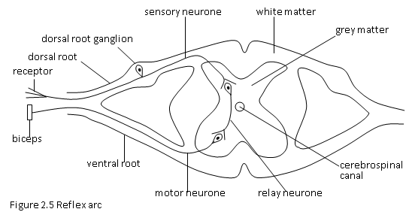

The spinal cord has two main functions.
▪It is the coordinating centre for the involuntary actions (reflexes).
▪It provides a means of communication between the brain and spinal nerves.
Illustration of the spinal cord

PERIPHERAL NERVOUS SYSTEM
The peripheral nervous system consists of nerves outside the central nervous system. Structurally, it consists of paired cranial nerves and spinal nerves. The cranial nerves originate in the brain and innervate the sense organs and muscles of the head and neck. The spinal nerves originate in the spinal cord and serve the receptors and effectors in the rest of the body.
The peripheral nervous system is functionally divided into two categories
- The somatic nervous system consists of the nerves leading to the skeletal muscles. It controls the voluntary activities e.g. walking, eating and singing.
- The autonomic nervous system controls the involuntary activities (responses).It consists of the (motor) neurones passing to the muscles of the viscera (internal organs) e.g. lungs, heart, etc. The autonomic nervous system consists of two subdivisions. (a) The sympathetic nervous system. this comes into operation during emergencies when animals are in danger. It helps them to respond to crises (fight or flight responses).
- The parasympathetic nervous system produces responses antagonistic [opposite] to those produced by the sympathetic nervous system. Its nerves slow down body activities and divert energy to basic processes such as digestion, sperm formation, e.t.c. The two systems tend to act antagonistically on the same organs.

Table showing activities of sympathetic and parasympathetic nervous systems
Parasympathetic N.S | Sympathetic N.S
Pupil of the constrict | Pupil of the eye dilates
Salivary glands inhibited | Salivary glands stimulated
Reduces heart beat rate | Accelerates heart beat rate , constricts arteries
Bronchi of lungs constrict | Bronchi of lungs dilate
Stimulates secretion in stomach | Inhibits secretion in stomach
Intestine peristalsis stimulated | Intestine peristalsis inhibited
Bladder muscles contracted | Bladder muscles inhibited
Sexual organs inhibited | Sexual organs stimulated

STRUCTURE AND FUNCTION OF A SYNAPSE
An impulse is received by the dendrite and passed to the cell body through the Dendron. It passes to the axon and finally to the dendrite of the adjacent neurone. There are no direct connections between the neurones. Instead, there are synapses.

Illustration of the synapse

Leaves 15lines

Qn describe how an impulse passes the synapse
When an impulse arrives at the end of a dendrite in the presynaptic knob, it causes the production of a chemical called acetylcholine [neuro-transmitter substance], from the vesicles in the presynaptic knob which diffuses across the synaptic cleft onto the post-synaptic membrane of the adjacent neurone where chemoreceptors detect it and then generates an impulse in the post synaptic neuron.
Explain functions of the synapse
- At a synapse,
- The impulse is transmitted in one direction thus synapse promote unidirectional flow of the impulse
- Synapse enable impulse transmission when enough stimulation has occurred at the receptor
- Enable channelling of an impulse from one nerve to many nerves which it connects
RESPONSES
The responses controlled by the nervous system fall into three categories i.e. voluntary actions, involuntary (reflex) actions and conditioned reflexes.
- Voluntary actions are responses controlled by the higher centres of the brain. They are done when an individual is aware of them (consciously). Since they involve thinking, the individual can decide to respond or not.
- Involuntary actions (simple reflexes) are quick, automatic responses that do not involve the higher brain thus are done out of will (unconsciously).
Simple reflexes are:
▪Instinctive (inborn).
▪Automatic (one does not think about what to do).
▪Quick (the response follows immediately).
▪Stereotyped (a particular stimulus produces the same response).
▪Usually advantageous.
Simple reflexes include heartbeat, vomiting, swallowing, peristalsis, salivation, sneezing, constriction of the blood vessels, blinking, withdrawal of the hand from painful stimuli, contraction of the urinary bladder and the knee jerk (patellar reflex). The path followed by impulses that cause a reflex action is called a reflex arc.

Example 1 (withdrawal of the hand)
When one touches a hot object [stimulus], temperature receptors in the hand are stimulated. They generate impulses, which travel along the sensory neurones. They enter the spinal cord via the dorsal root. In the grey matter, the impulses pass to the relay neurones in the CNS where interpretation takes place. The relay neurones generate impulses that pass to the motor neurones, which leave the spinal cord via the ventral root The motor neurones transmit the impulses to the biceps [effector], which contracts and withdraws the hand from the hot object.
Example 2 (knee jerk)
A tap on the knee exerts a sudden pull on the tendon connected to the quadriceps (thigh muscle) that extends the lower leg. Stretch receptors in the muscle detect the pull and are stimulated. They generate impulses that pass to the relay neurones where interpretation takes place. The relay neurones generate impulses that pass to the motor neurones. In turn, the motor neurones send impulses back to the quadriceps which contracts and jerks the lower leg forward.
Differences between reflex actions and voluntary actions
Reflex action |  | Voluntary action
The response is immediate | The response is not immediate
The path of the impulses is short | The path of the impulses is long
Neurone pathways are in the spinal cord | Neurone pathways are in the brain
The response is always the same | The response varies
The skeletal muscle or involuntary muscle responds | Only the skeletal muscle responds
It is effected when one is not aware | It is effected when one is aware
It is instinctive | It may be learned
- CONDITIONED REFLEX AND PAVLOV’S EXPERIMENT
A conditioned reflex is a type of response elicited by a stimulus, which naturally does not cause it. Conditioned reflexes are based on research conducted on dogs by a Russian biologist named Ivan Pavlov. He made them salivate in response to the sound of the bell, an otherwise useless stimulus to dogs, by pairing it with food for some time. The dogs eventually salivated upon hearing the sound of the bell alone. They had learned to associate the relevant stimulus (smell of food) known as the unconditioned stimulus with an irrelevant stimulus (sound of the bell) known as the conditioned stimulus. Salivation in response to the sound of the bell is an example of a conditioned reflex. The original salivation reflex is the unconditioned reflex. It is inborn and does depend on the experience of the animal.
Differences between simple reflexes and conditioned reflexes
Simple reflex | Conditioned reflex
It involves one stimulus | It involves more than one stimulus
It is controlled by the spinal cord | It is controlled by the brain
It takes a short time to effect | It takes a long time to effect
It does not involve learning | It involves learning
It does not involve association of stimuli | It involves association of stimuli
QN. Compare hormal control system and th nervous system?
- Similarities [6lines]
- Differences [ Leave 10lines]
SENSE ORGANS
A sense is a faculty that enables an animal to perceive information about a stimulus. The five basic senses are sight (vision), hearing, gustation, olfaction and touch. A group of receptors forms a sense organ e.g. eye, ear, tongue, nose and skin.
THE MAMMALIAN EYE
The mammalian eye contains photoreceptors (receptors that are sensitive to light). The eye is held in a protective, bony socket of the skull called the orbit by the rectus muscle
The sclera is a tough, non-elastic covering that protects the eyeball.
The cornea is a curved, transparent part of the sclera. It refracts light towards the retina.
The conjunctiva is a thin transparent layer of cells protecting the cornea. It is continuous with the epithelium (inner surface) of the eyelids.
The choroid is a black (pigmented), highly vascularized layer of tissue lining the inside of the sclera. It prevents the reflection (scattering) of light within the eyeball. Its blood vessels supply oxygen and nutrients to the eye. The blood vessels remove metabolic wastes from the eye.
The ciliary body is the thickened end of the choroid that contains the ciliary muscle which changes the shape of the lens to facilitate accommodation. The ciliary body produces the aqueous humour.
The suspensory ligaments maintain the position of the lens (transparent, biconvex structure) that focuses light to the retina and separates the aqueous humour from the vitreous humour.
The aqueous humour supplies nutrients to the eyeball, maintains the shape of the anterior chamber of the eyeball and refracts light to the retina. The iris is a pigmented structure that regulates the amount of light entering the eye (by adjusting the size of the pupil).
The pupil is an opening in the iris that allows light to enter the eye.
The vitreous humour maintains the shape of the posterior chamber of the eyeball and refracts light to the retina.
The retina is a layer of photoreceptors (cones and rods). The cones are sensitive to colour and bright light. They are responsible for accurate vision. The greater the number of cones on a given area of the retina, the keener is the sense of sight. The rods are sensitive to dim light. They are more numerous than cones. They are important light receptors in nocturnal animals e.g. bats.
The fovea (yellow spot) is the most sensitive part of the retina because it has a high density of cones.
The optic nerve transmits impulses to the optic lobes of the brain for interpretation. The part of the retina at which the optic nerve and blood vessels enter the eye is known the blind spot. Since it has no photoreceptors, no image forms on it. The eyebrows and eyelashes prevent foreign bodies e.g. dust from entering the eye.
The eyelids protect the eye from mechanical injury. Blinking (opening and closing of the eyelids) distributes fluid over the surface of the eye. This prevents desiccation in addition to washing away foreign bodies.
The lachrymal (tear) glands secrete the lachrymal fluid, which enters the eye through the lachrymal ducts. The lachrymal fluid keeps the conjunctiva moist and washes away foreign bodies. It contains lysozyme, an enzyme that destroys bacteria by disrupting the polysaccharide components of the cell walls.
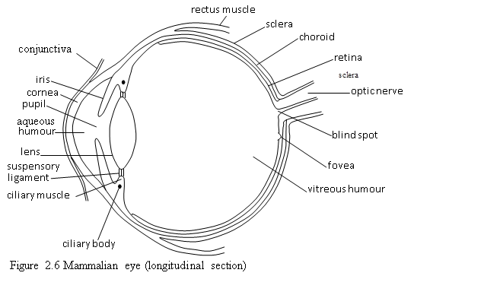
Image formation
Light from the object, passes through the conjunctiva, cornea, aqueous humour and vitreous humour. The curved surfaces of the cornea and lens refract the light rays to the retina. On the retina, the image formed is upside down and smaller than the object. Light stimulates the photoreceptors, which generate impulses. These are transmitted through the optic nerve to the brain where the image is interpreted into a normal-sized, upright and coloured one.
Eye accommodation
Accommodation is the ability of the eye to see clearly bot far and distant objects
This is possible because the eye is able to adjust the size of the lens hence its focal length. Accommodation is caused by the action of the circular ciliary muscles. Parallel rays from a distant object are focused when the ciliary muscles relax. This increases tension in the suspensory ligaments, which stretch the lens and make it thin hence less refracting hence focuses the image to the retina from which photo receptors generate impulses which are taken by optic nerve to CNS to interpret.(figure A). Nearby objects are seen when these cilliary muscles contract and reduce tension in the suspensory ligaments. This makes the lens thicker hence more refracting to focus the image to the retina [figure B].

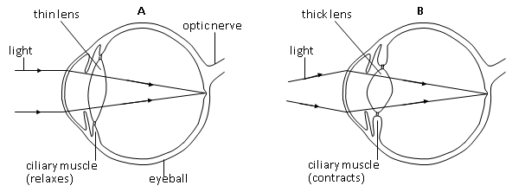
Control of light intensity
In bright light, the circular muscle of the iris contracts while the radial muscle relaxes. The pupil size becomes smaller thus less light enters the eye and the retina is protected from damage by strong light. In dim light, the circular muscle of the iris relaxes while the radial muscle contracts leading to the dilation of the pupil. The dilation of the pupil results in the admission of sufficient light capable of stimulating the photoreceptors on the retina.
Adjustments in bright light
Adjustments in dim light
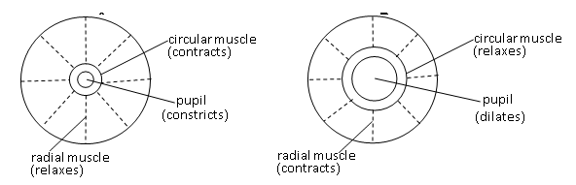
Defects of the eye
Defects occur when the eye cannot focus light to the retina. They are different from eye diseases e.g. river blindness, trachoma and conjunctivitis that are due to infection.
Short sight (myopia) is a defect whereby a person can see clearly objects that are nearby but not distant ones. Light from a distant object is focused before the retina because of large or elongated eyeballs. Short sight is corrected by putting on spectacles with concave (diverging) lenses
Long sight (hyperopia) is a defect whereby a person can see clearly objects that are far. Light from a nearby object is focused behind the retina because of small eyeballs. It is corrected by putting on spectacles with convex (converging) lenses.
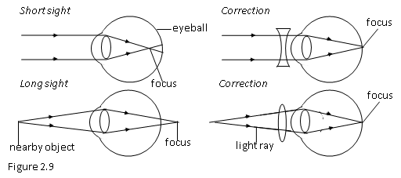
Old sight (presbyopia) is the declining ability to focus nearby objects as one becomes old. The lens loses its elasticity and it has a fairly fixed shape that is able to focus distant objects. This is why most old people require reading glasses (bifocal lenses).
Astigmatism occurs when the surface of the cornea or lens is not spherical (more sharply curved in one plane than another). Light rays scatter in various directions instead of converging at a single point on the retina. It is corrected by using cylindrical lenses.
MAMMALIAN EAR
The ear has mechanoreceptors (receptors that detect physical deformation) associated with sound, gravity and displacement.
The ear performs three basic functions i.e. detection of:
- ▪Sound (hearing).
- ▪Head movements.
- ▪Changes in gravity (balance or posture).
The ear consists of three sections i.e. outer ear, middle ear and inner ear (Figure 2.10). The outer projecting portion of the outer ear is known as the pinna (auricle). Its function is to receive and concentrate sound waves. The auditory canal has hairs and wax that trap foreign bodies. It transmits sound waves to the eardrum (tympanum), which is a thin membrane. The eardrum transmits sound waves to the middle ear. The three small bones i.e. hammer (malleus), anvil (incus) and stapes (stirrup) are known as ossicles. They transmit sound vibrations from the eardrum to the oval window. The Eustachian tube is a slender canal that connects the middle ear to the pharynx. It equalizes the air pressure on the two sides of the eardrum. The oval window (fenestra ovalis) transmits sound vibrations to the inner ear. The semi-circular canals, utriculus and sacculus form the vestibular apparatus, which controls body balance and orientation. The cochlea facilitates hearing. The round window (fenestra rotunda) equalizes pressure in the cochlea. The auditory nerve transmits impulses to the brain.
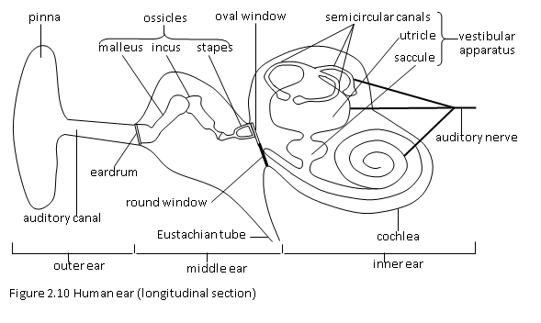
26

HEARING
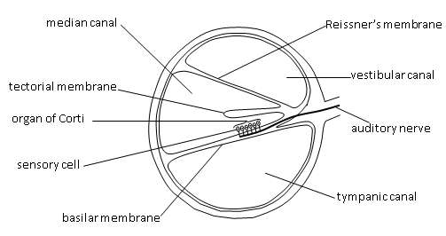
The pinna receives and concentrates the sound waves. They are transmitted to the eardrum, which vibrates. The vibrations of the eardrum are transmitted to the ossicles that vibrate and transmit the vibrations to the oval window at the entrance of the vestibular canal of the cochlea. The perilymph (fluid) in the vestibular canal vibrates and causes Reissner’s membrane to vibrate. The displacement of Reissner’s membrane causes the endolymph in the median canal to vibrate, which in turn causes the basilar membrane to vibrate. The vibration of the basilar membrane stimulates sensory cells (in the organ of Corti), which generate impulses. The impulses are transmitted by the auditory nerve to the brain, which interprets them into sounds. The vibrations of the basilar membrane disturb the perilymph in the tympanic canal. The round window takes up these vibrations.

TONGUE
The tongue is a sense organ for gustation (taste), which is detected by receptors known as taste buds. Since taste is due to the presence of chemicals in the mouth, taste buds are chemoreceptors. Depending on the distribution of taste buds on the tongue, the receptors detect four kinds of (primary) tastes i.e. bitter, salty, and sweet and sour (Figure 2.14).
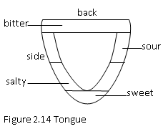

NOSE
The nose is a sense organ for olfaction (smell). Chemicals dissolve in the mucus lining of the nasal cavity and stimulate the chemoreceptors in the nasal epithelium. The chemoreceptors generate impulse to the brain via the olfactory nerve. Olfaction plays an important part in distinguishing the different flavours.
SKIN
The skin has receptors e.g. Krause end bulbs (sensitive to texture), Ruffini corpuscles (sensitive to pressure), nerve endings (sensitive to pain), Pacinian corpuscles (sensitive to pressure) and Meissner corpuscles (sensitive to touch)

Illustration of the human skin
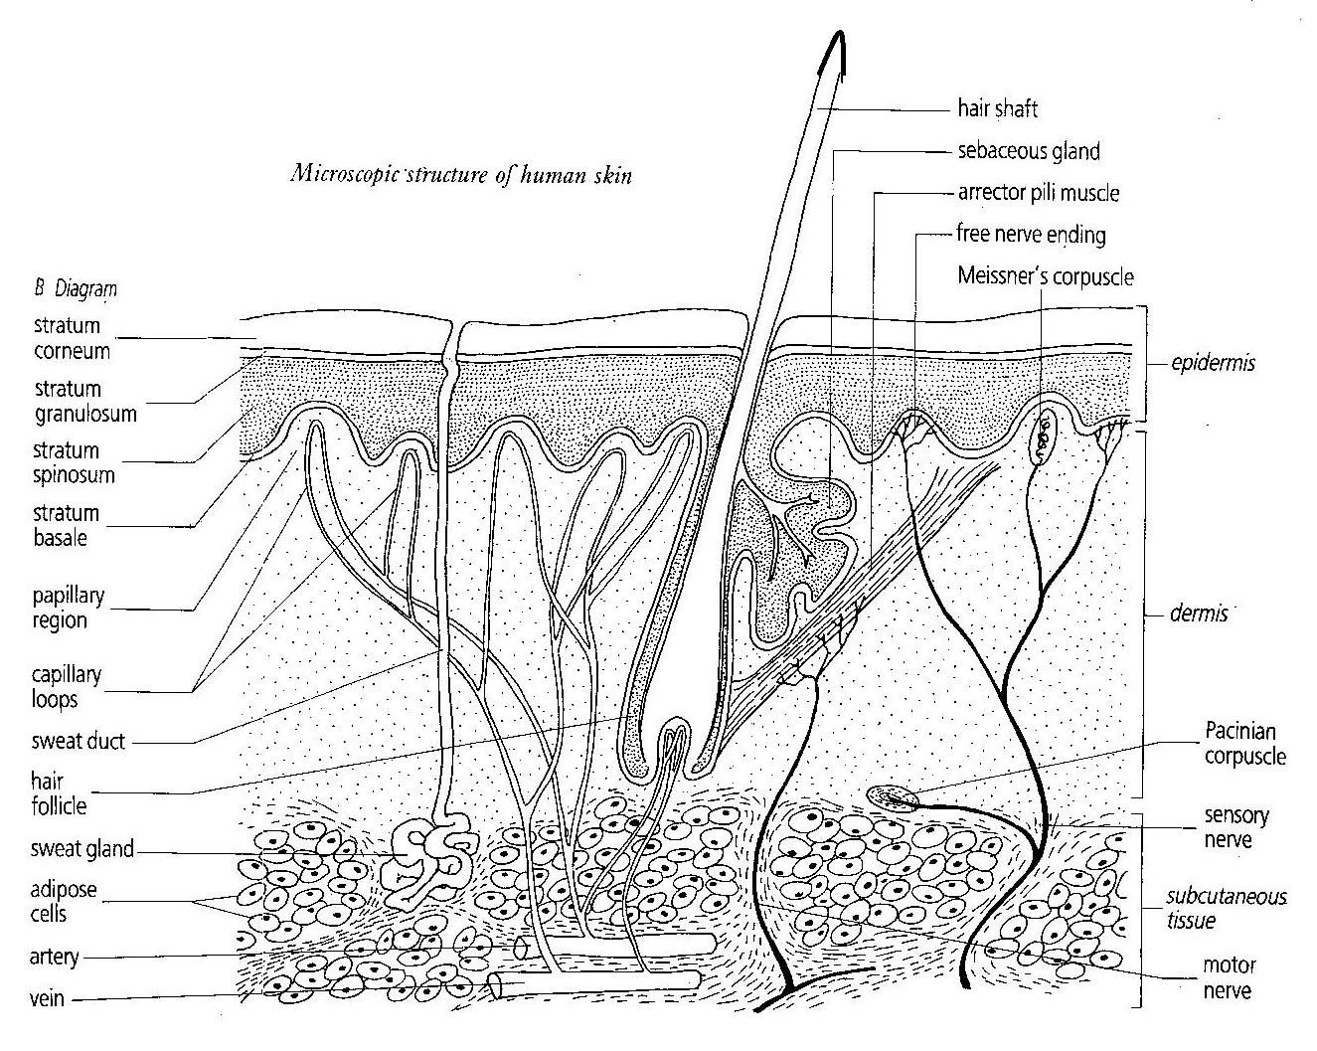
END OF COORDINATION

